**Experiment 29**

**AIM :**

To design DFA transition diagram of creating string abc at the end in automata.

**Design and output:**

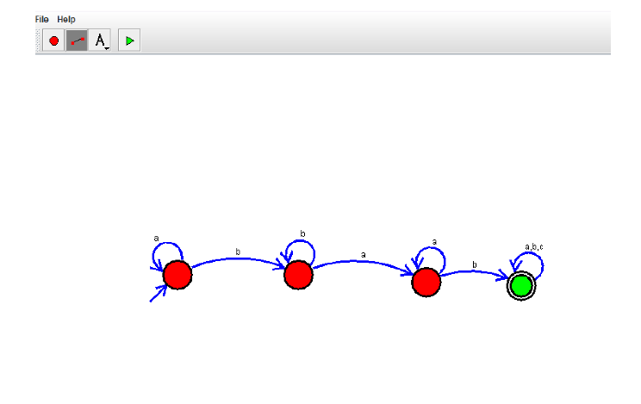

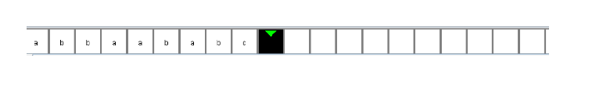

**Result:** Thus designing DFA transition diagram of creating string abc at the end is done and verified by giving sample inputs.